Chapter 8: Transport in Plants
Plants have specialized transport systems to move water, mineral ions, and manufactured food substances (sugars) throughout their bodies. These systems are crucial for their survival and growth.

8.1 Xylem and Phloem
Plants possess two main types of vascular tissues for transport:

- Xylem: Responsible for the transport of water and mineral ions from the roots to the rest of the plant. It also provides structural support to the plant.
- Phloem: Responsible for the transport of sucrose (sugar produced during photosynthesis) and amino acids from the leaves to other parts of the plant where they are needed for growth or storage.

Position of Xylem and Phloem
In non-woody dicotyledonous plants, xylem and phloem are found together in vascular bundles. Their arrangement varies in different parts of the plant:

- Roots: Vascular bundles are typically in the center, with xylem forming a star shape and phloem located between the arms of the xylem.
- Stems: Vascular bundles are arranged in a ring, with xylem usually towards the inside and phloem towards the outside.
- Leaves: Xylem and phloem are found in the veins of the leaf.
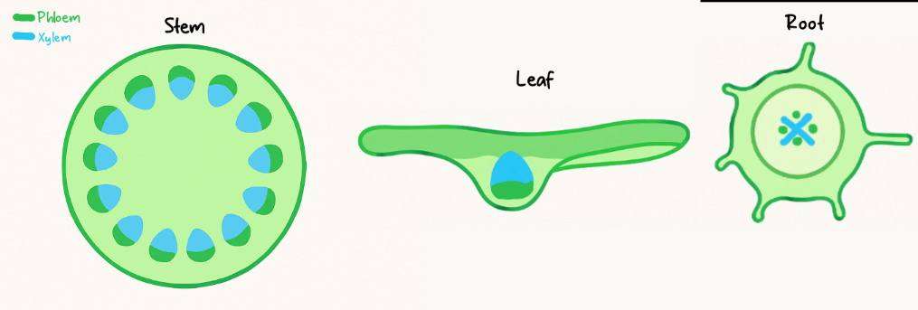

Structure of Xylem Vessels and Function
Xylem vessels are specially adapted for efficient water transport and support:

- Thick walls with lignin: Xylem vessels have thick cell walls strengthened with lignin. Lignin provides structural support, preventing the vessels from collapsing under tension and making them waterproof.
- No cell contents: Mature xylem vessels are dead cells and lack cytoplasm, nucleus, and other organelles. This creates a hollow tube, reducing resistance to water flow.
- Cells joined end to end with no cross walls: Xylem cells are joined end to end, and their end walls break down to form a continuous, long, hollow tube. This allows for an uninterrupted column of water to be transported.

8.2 Water Uptake
Plants absorb water and mineral ions from the soil primarily through their roots.

Root Hair Cells
- Root hair cells are specialized epidermal cells in the root that have long, thin extensions (root hairs).
- Function: These root hairs significantly increase the surface area of the root, which is crucial for the efficient uptake of water by osmosis and mineral ions by active transport.

Pathway of Water Through the Plant
Water moves from the soil, through the root, stem, and eventually to the leaves:

- Root hair cells: Water enters the root hair cells from the soil by osmosis.
- Root cortex cells: Water then moves across the root cortex cells.
- Xylem: Water enters the xylem vessels in the center of the root.
- Stem: Water is transported upwards through the xylem in the stem.
- Mesophyll cells (Leaves): From the xylem in the leaves, water moves into the mesophyll cells, where it is used for photosynthesis or evaporates into the air spaces.

Investigating Water Pathway
The pathway of water through the above-ground parts of a plant can be investigated using a suitable stain (e.g., eosin or food dye). When a plant is placed in stained water, the dye is drawn up through the xylem vessels, making them visible when the stem or leaf is cut in cross-section.

8.3 Transpiration
Transpiration is the loss of water vapor from plant leaves to the atmosphere, through the stomata.

Mechanism of Transpiration
- Evaporation: Water evaporates from the surfaces of the mesophyll cells into the air spaces within the leaf.
- Diffusion: The water vapor then diffuses out of the leaf through small pores called stomata, which are mainly located on the underside of the leaf.
- Transpiration Stream: The loss of water from the leaves creates a transpiration pull or tension in the xylem vessels. This pull, combined with the cohesive forces between water molecules (due to hydrogen bonding) and adhesive forces between water molecules and xylem walls, draws a continuous column of water upwards from the roots to the leaves. This movement is known as the transpiration stream.

Importance of Transpiration
- Water transport: Drives the movement of water and dissolved mineral ions from the roots to the leaves.
- Cooling: Evaporation of water from the leaf surface helps to cool the plant, preventing overheating.
- Turgor: Maintains turgor pressure in plant cells, which provides structural support.

Factors Affecting Transpiration Rate
The rate of transpiration is influenced by several environmental factors:

- Temperature: Higher temperatures increase the kinetic energy of water molecules, leading to a faster rate of evaporation and diffusion, thus increasing transpiration.
- Humidity: High humidity means there is a high concentration of water vapor in the air, reducing the water potential gradient between the leaf and the atmosphere. This decreases the rate of diffusion and thus transpiration.
- Wind speed: Increased wind speed removes water vapor from around the stomata, maintaining a steep water potential gradient and increasing the rate of transpiration.
- Light intensity: Increased light intensity causes stomata to open wider to allow more carbon dioxide for photosynthesis, which also increases the rate of water vapor diffusion and thus transpiration.

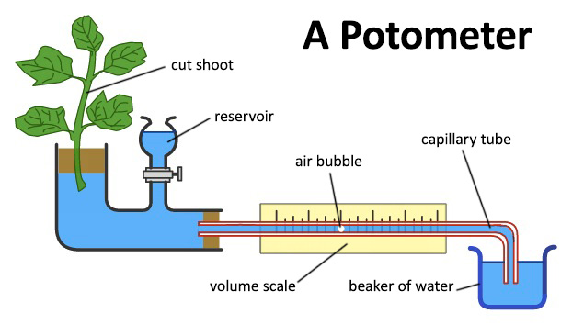
Measuring Transpiration Rate
A potometer is a device used to measure the rate of water uptake by a plant, which is an indirect measure of the transpiration rate. The movement of an air bubble in a capillary tube indicates the volume of water absorbed by the plant over time.

8.4 Translocation
- Translocation: is the transport of dissolved organic substances, primarily sucrose and amino acids, throughout the plant. This process occurs in the living phloem tissue. The flow of these substances is always from a source (where produced) to a sink (where used/stored).

Sources and sinks.
Sources: These are the parts of a plant that produce or release sucrose or amino acids.
Sinks: These are the parts of a plant that use or store sucrose and amino acids.

Explain why some parts of a plant may act as a source and a sink at different times.
The role of a plant part (whether it is a source or a sink) is not fixed; it changes depending on the plant's stage of development and the season. This is because the needs of the plant change over time.

Key Concept: A plant part is a source when it is exporting sugars, and a sink when it is importing them.
Here are the main examples:

1. A Storage Organ (e.g., a Potato Tuber, Onion Bulb)
- Sink (During Summer/Growing Season):
  - The plant is actively photosynthesizing in its leaves (sources).
  - The tuber is receiving sucrose from the leaves and converting it into starch for long-term storage.
  - It is importing food, so it is a sink.
- Source (During Spring/Germination):
  - The plant needs energy to grow new shoots.
  - The tuber mobilizes its stored starch, converting it back into sucrose.
  - It then exports this sucrose to the growing shoots and roots.
  - It is now exporting food, so it is a source.

2. A Growing Leaf
- Sink (When it is young and pale):
  - A young leaf cannot yet photosynthesize enough to meet its own energy needs for rapid growth.
  - It imports sucrose from mature, older leaves to support its development.
  - It is importing food, so it is a sink.
- Source (When it is mature and green):
  - Once the leaf is fully expanded and green, it photosynthesizes efficiently.
  - It now produces more sucrose than it needs and exports the excess to other parts of the plant like roots, fruits, or storage organs.
  - It is now exporting food, so it is a source.

3. A Developing Fruit or Seed
- Sink (During its growth and development):
  - Throughout its growth, a fruit or seed is a major sink, importing vast amounts of sucrose and amino acids to be converted into storage compounds (e.g., starch in wheat grains, oils in sunflower seeds, sugars in fruits).
- Source (When the seed germinates):
  - Once the seed germinates, the stored food within the seed is broken down and transported to the growing root and shoot of the new seedling.
  - At this stage, the seed itself acts as a source for the new plant.

